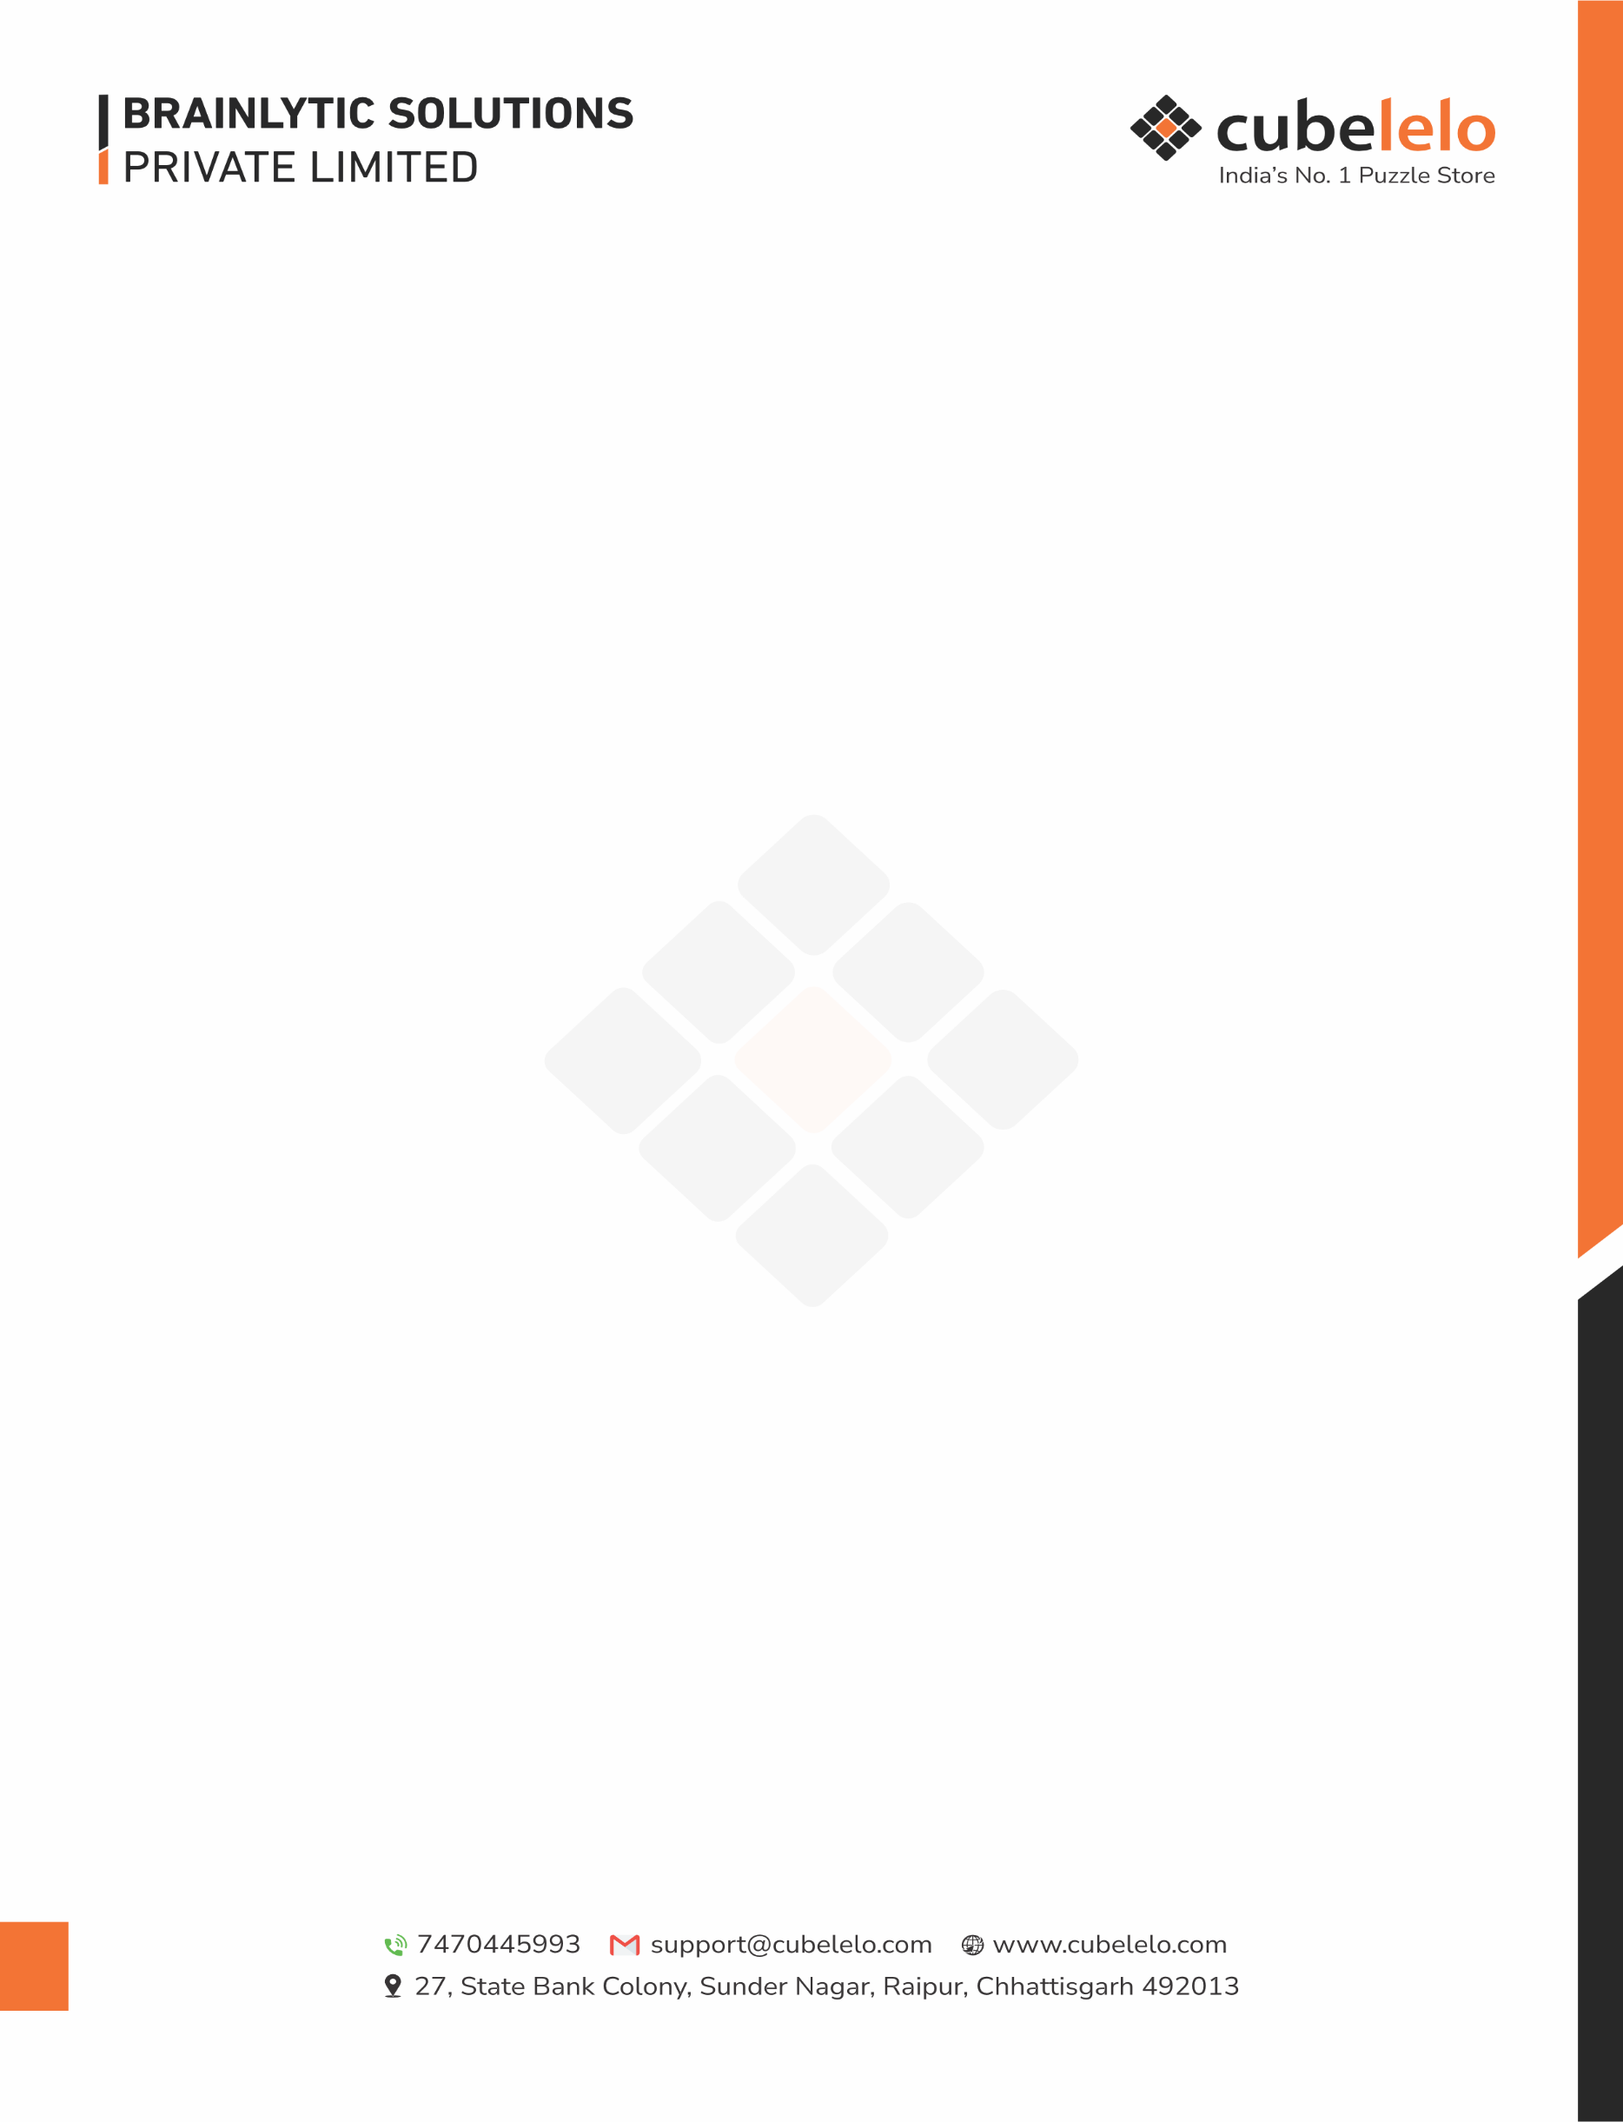
Date – 04th May 2026
Sub: Internship Letter

Vedant Dubey,
We refer to your recent discussions with us and are pleased to offer you the position of
Process Innovation Intern. Your job location will be Raipur.
Your date of joining will be 11th May 2026.
You will be under internship for a duration of 2 months.
Your reporting manager will be Mr. Harsh Jain (Growth & Marketing Manager).
Your Stipend amount during internship period will be Rs.15,000/- (Rupees Fifteen Thousand)
per month.

Please submit copies of the following documents and produce originals wherever required:
● 2 Passport size photographs.
● Copy of Educational certificates (From Std. X till graduation/PG/Ph.D. etc.)
● Relieving certificate, salary slip/certificate of the last pay drawn from the previous
employer/Copy of Resignation duly accepted by Current Employer.
● Experience certificate from all past/previous employers.
● Form 16 and proof of earnings for the past year (in case of employed personnel)
● Aadhar Card, Pan Card & Address Proof.
● Bank Passbook

If you find the above terms of employment acceptable, you are requested to sign a copy of this
offer letter as a token of acceptance and submit it back to us.

For, For,

Brainlytic Solutions Pvt. Ltd. Vedant Dubey

